REPORT

CUSTOMER REF NO.: | PO113342
ALS THAILAND REF NO.: | ATT/ELP/15/1110-CORB
DATE: | 14 August 2015
COMPANY: | Saint Gobain Performance Plastics Rencol Ltd.
 | Unit 16 Concorde Rd. Patchway , Bristol, BS34 5TB
DATE SAMPLE RECEIVED: | 29 July 2015
DATE ANALYZED: | 05 August 2015
DATE TEST COMPLETED: | 10 August 2015

SAMPLE DESCRIPTION: | One lot of sample was received with references:
 | Description: RING6354G
 | Model: B226252
 | Surface Area: 2.31 cm2
 | Remark: Seagate Monthly

METHOD/PROCEDURE:
Test | Procedure No | Number of pieces  used for extraction
Corrosion test | 20400058-001 Rev B | 32

ALS THAILAND REF NO.: | ATT/ELP/15/1110-CORB
DATE: | 14 August 2015
COMPANY: | Saint Gobain Performance Plastics Rencol Ltd.

RESULTS:
The specification is based on Seagate's document no.20400058-001 Rev BF
Temperature Humidity Parameters | Specification | Result
85oC, 85%RH, 24hours | No observable discoloration or spots at 10x | Pass
Photo Before: Photo After:
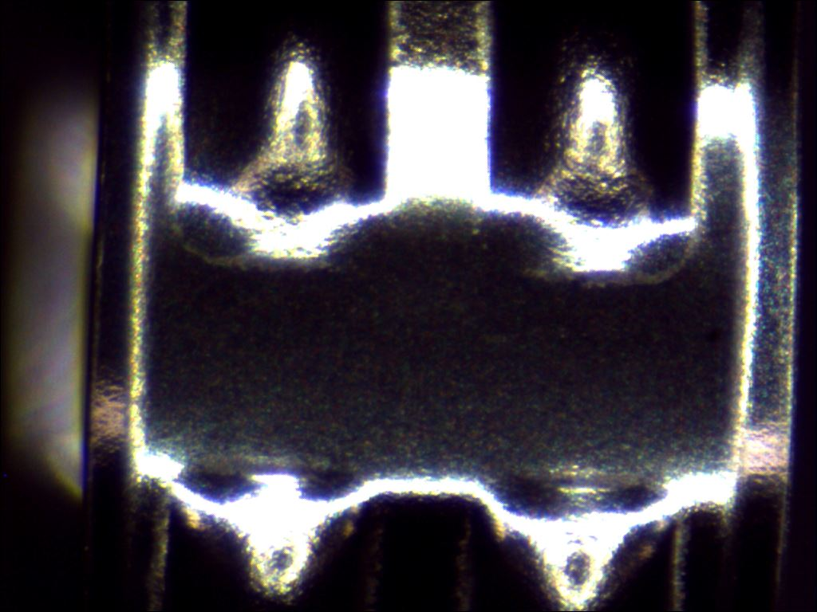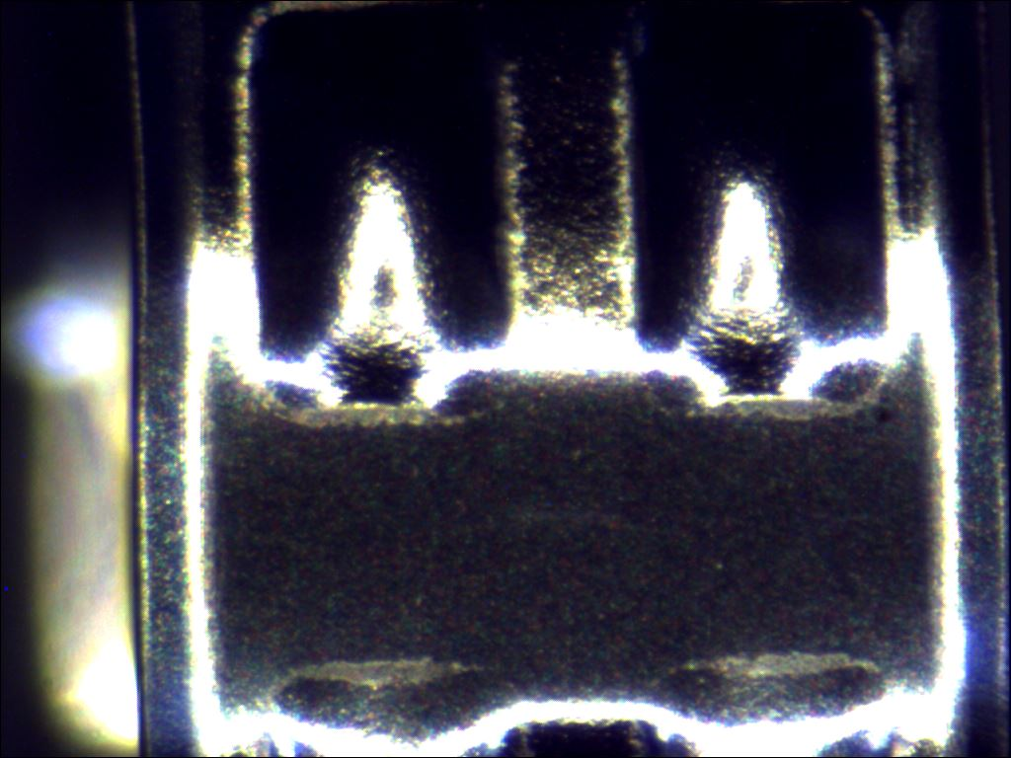

Remark:
1.) The result related only to the test items.
2.) The test report shall not be reproduced except in full, without written approval of ALS Testing Services (Thailand) Co., Ltd.

- END OF REPORT -

ALS Testing Services
(Thailand) Co.,Ltd.
-----------------------------------
Warunee Maneesuwan
M.Sc, B.Sc, Laboratory Manager

